Contents

Comparison 2

Setup Instance in AWS 4

Few Commands 8

Install java runtime 8

Ansible Facts 9

Ansible Modules 9

# Comparison

[Training - Google Drive](https://drive.google.com/drive/folders/1ObsIMe89ojedRjCTN82ZKRH-h-WMajDU)

[Ansible Configuration - Google Drive](https://drive.google.com/drive/folders/1tsJIkW7tJ4V5L288ggeAuHTOiJVy6_Pv)

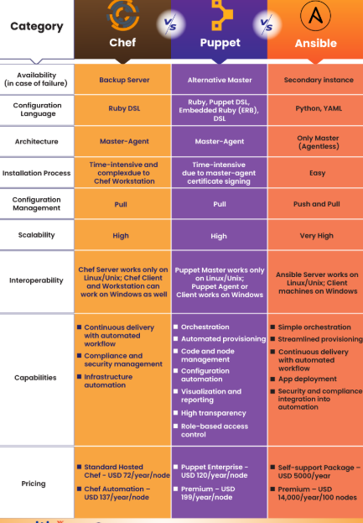

Puppet – 2006

Chef – 2009 Cloud based



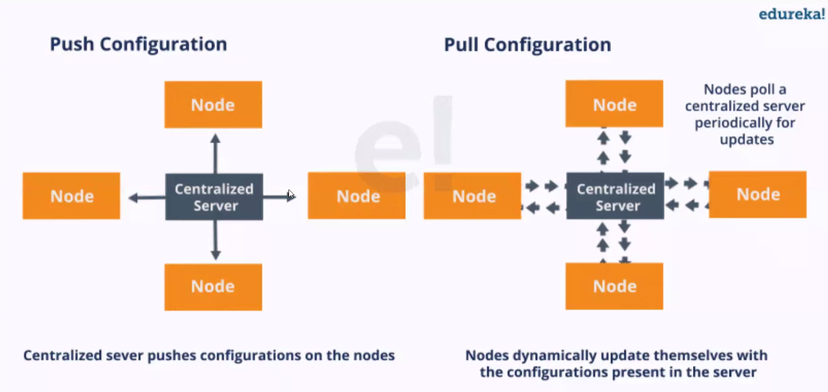

# Setup Instance in AWS

1. For AWS Credentials, get the credentials and will be reset every 6 hours and need to follow same steps again.

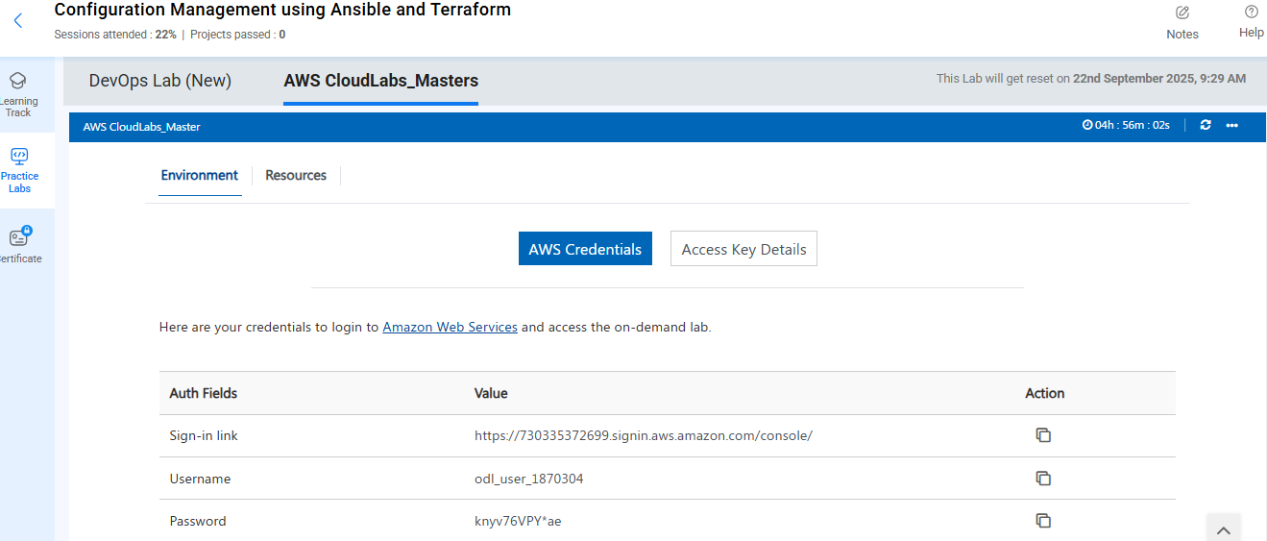

1. Select region as United States (N.Virginia)



1. From EC2 >> Instances >> Launch an instance

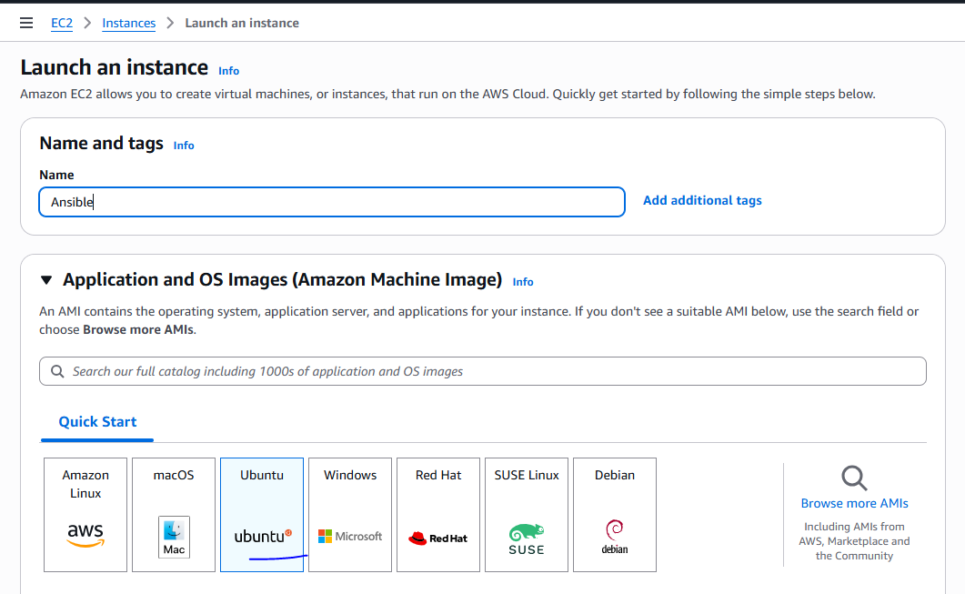

1. Keep instance type as t2.micro

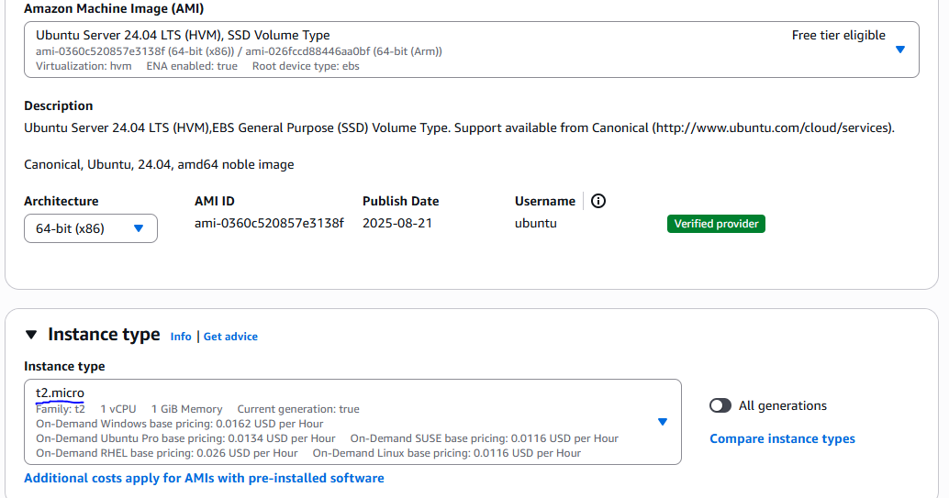

1. For Key Pair, create a new key pair and download .pem file

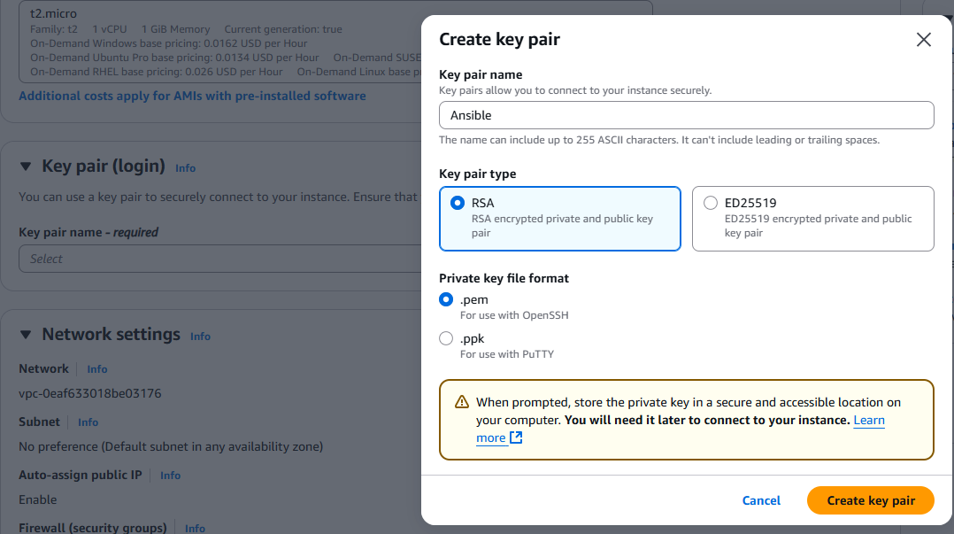

1. In Summary 3 instances and launch

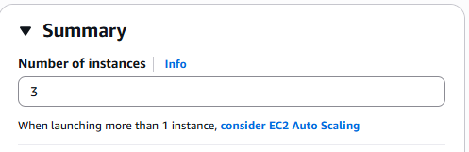

1. It will take few minutes to create 3 instances.
2. Click View All instances to view them
3. Rename instances for better clarity

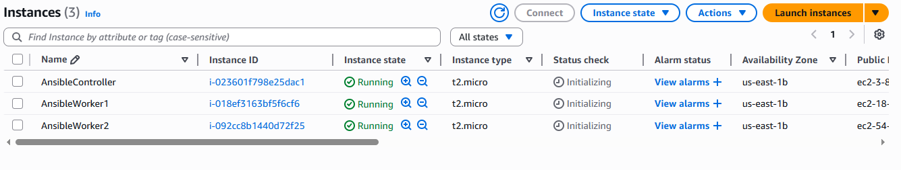

1. Copy the pem file into users directory and open terminal
2. Select AnsibleController >> Connect and in the SSH client get the command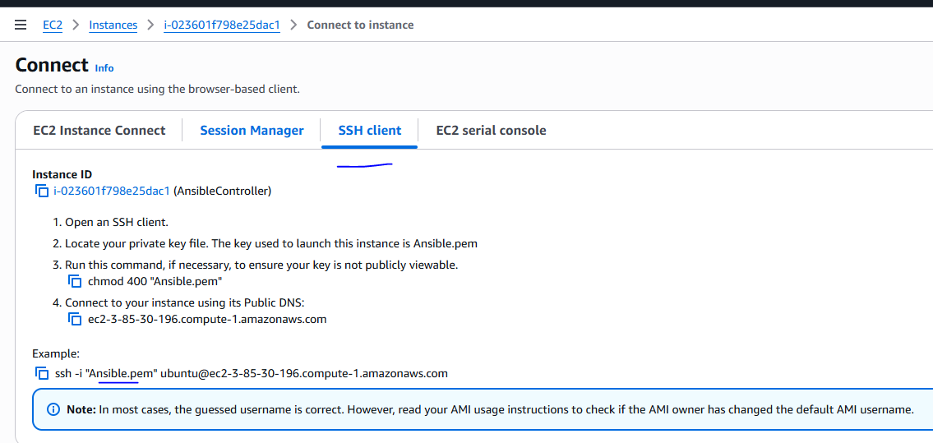
3. Execute the command in the terminal

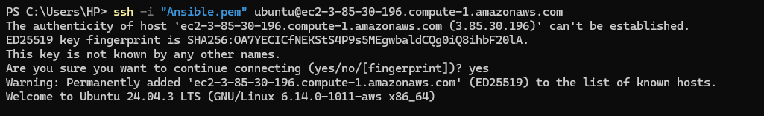

1. Will be connect to the AnsibleController host. And switch to root user
2. Follow the steps in [Ansible&Terraform - Google Docs](https://docs.google.com/document/d/1pK5bgOUo-f6fChtLjp8aslWwnyl0KFi18nQi_1yg_Io/edit?tab=t.0)
3. Install ansible using the command

apt update && apt -y install ansible

1. Get the ansible version

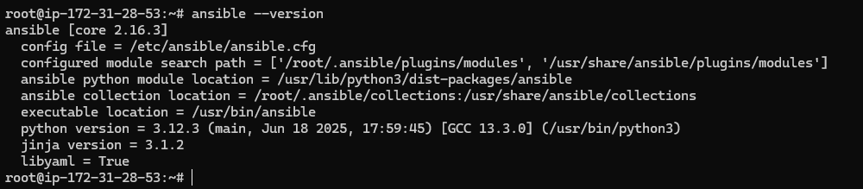

1. In AWS, get the private IPV4 address of both worker nodes. (As if in same region, can use private IPs else need to use public IPs)
2. Execute the command

mkdir /etc/ansible

ansible-config init --disabled -t all > /etc/ansible/ansible.cfg

1. Copy Ansible.pem file from local system user directory to /etc/ansible/
2. Create hosts file into /etc/ansible/hosts

[webservers]

172.31.29.34

172.31.25.238

172.31.25.234

[webservers:vars]

ansible_ssh_port=22

ansible_ssh_user=ubuntu

#ansible_ssh_password=password

ansible_ssh_private_key_file=/etc/ansible/Ansible.pem

1. #Disables Host key check validation

export ANSIBLE_HOST_KEY_CHECKING=Falsechmod 400 ansible.pem

1. chmod 600 Ansible.pem #to restrict from all users

export ANSIBLE_HOST_KEY_CHECKING=False

1. ansible -m ping webservers # while executing, will be able to see all hosts

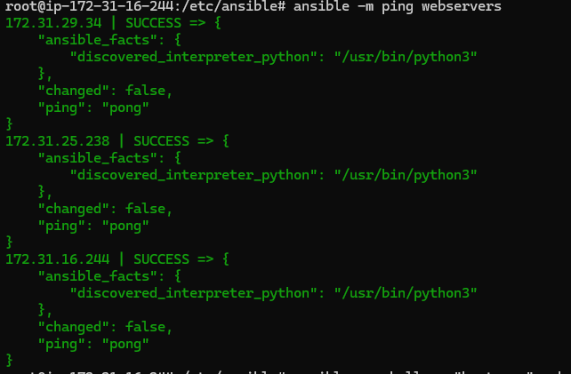

1. Execute **apt update** to fetch recent updates. Run 'apt list --upgradable' to see them.
2. We can also have different pem file, different ports in host file.

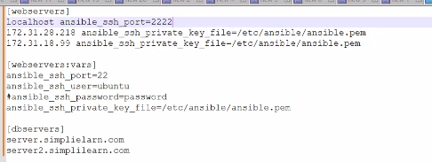

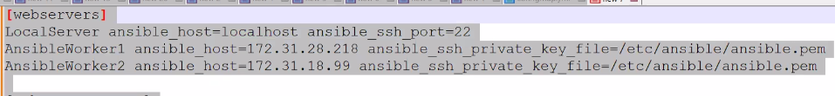

# Few Commands

ansible -m shell -a "hostname" webservers 🡪 execute shell command to the webservers Here execute hostname command in each of the servers.

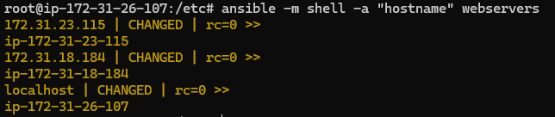

## Install java runtime

ansible -m shell -a "apt update && apt -y install default-jdk" webservers

Will throw error because in the hosts file, we asked to use Ubuntu user only



ansible -m shell -a "apt update && apt -y install default-jdk" webservers --become

Will use to become that particular user

ansible -m shell -a "java --version" webservers --become

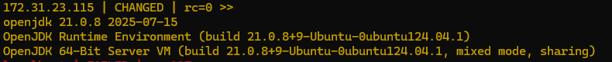

ansible -m shell -a "java --version" webservers all –limit “!server.hostname” 🡪 Will ignore one host.

# Ansible Facts

In Linux and Windows systems env and set command will give environment variables.

When connecting to a machine, we collect some variables which are metadata. Collecting the environment details is Ansible Facts.

ansible -m setup all #here setup is a module which provides all info such as OS, IP Address, DNS etc

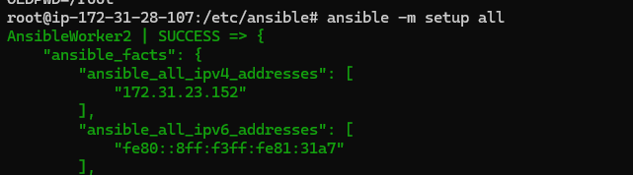

# Ansible Modules

[Module Index — Ansible Documentation](https://docs.ansible.com/ansible/2.9/modules/modules_by_category.html)

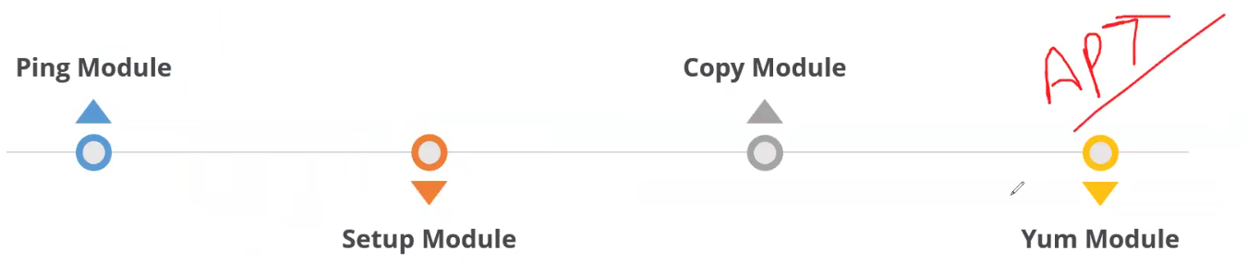

Yum – APT – used to install packages

Ansible module supports all clouds, docker, kubernetes, network etc

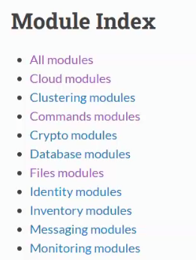 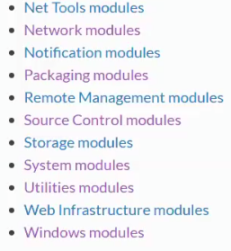

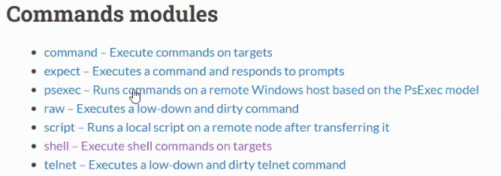

On clicking any commands will provide detailed info and examples as well.

# YAML

Ansible uses YAML files for Playbook.

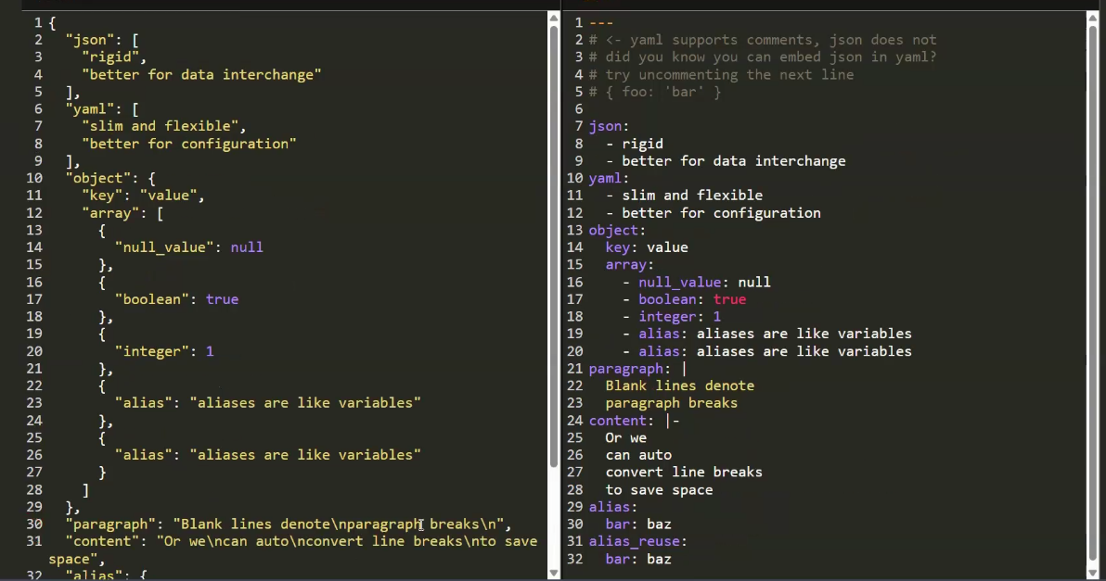

|and |- are almost same but |- will remove any leading spaces or blank lines.

<https://docs.ansible.com/ansible/2.9/modules/shell_module.html#shell-module>

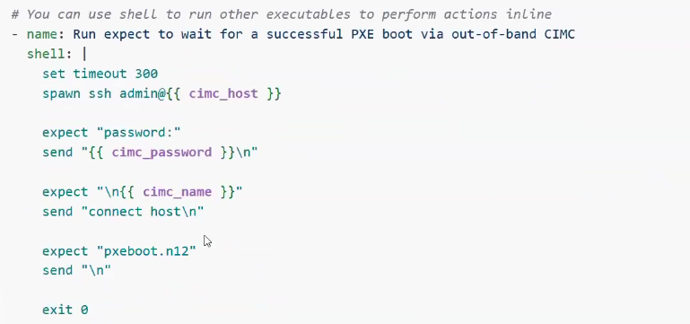

# Playbook

Defines set of tasks to execute in remote server such as package installation, folder creation/deletion, tasks execution, configuration management. Consists of tasks, hosts to be executed.

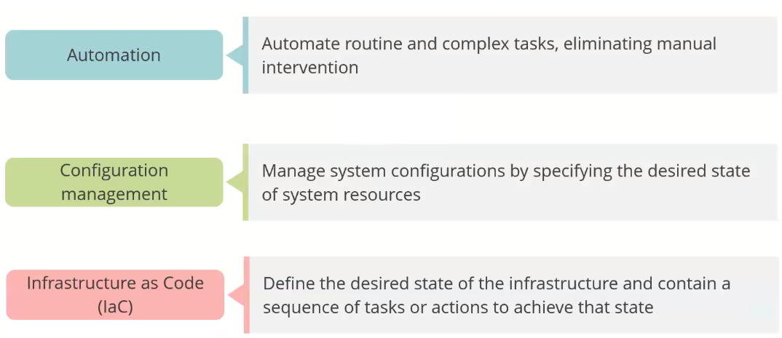

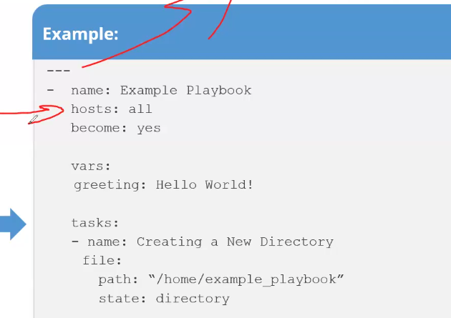

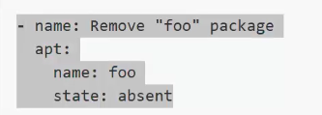

State present will install and absent/removed will remove

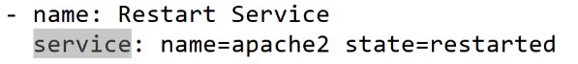

service apache2 stop

service apache2 start

service apache2 restart

Service module to perform action or fire a command.

Execute to download apache.yml file

wget <https://gist.githubusercontent.com/anujdevopslearn/8395705058c9cd4f4f5c3fec5591b246/raw/b3881336203696714fded02e100f75c80624cd66/apache.yml>

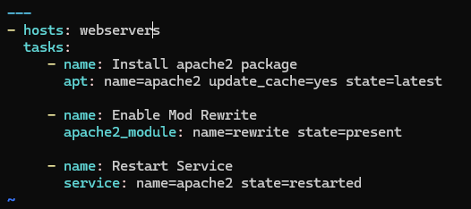

Execute the command 🡪 ansible-playbook apache.yml –b (or mention become: yes)

Test 🡪 ansible -m shell -a "curl localhost:80" webservers

Ansible will not repeat steps again as if same playbook is executed, installation will not be performed and only restart will happen.

## Access EC2

To access from browser for EC2,

Click Security >> Security groups >> Edit inbound rules.

Here port is opened only for ssh now enabled for web browser

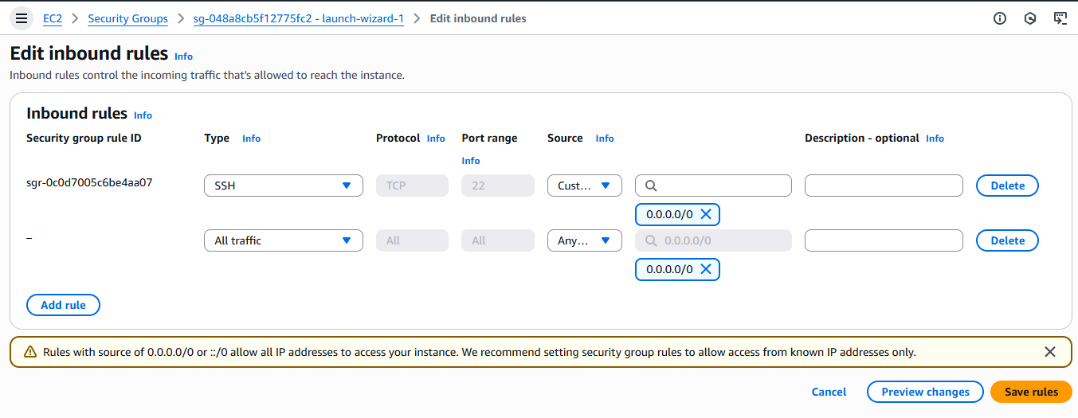

Checkout from Git

<https://docs.ansible.com/ansible/2.9/modules/git_module.html#git-module>